

CDS6344 Social Media Computing

TC2L / TT8L

G10

Dr. Haque Radiah

Sentiment Analysis and Opinion Mining of FIFA 23 Steam Reviews

Student Name | Student ID
Lai Cal Wyn | 1231303570
Yaser E H Abulaban | 1221305612

Assessment Form
Student Name | Student ID | Contribution (100%)
Lai Cal Wyn | 1231303570 | 50%
Yaser E H Abulaban | 1221305612 | 50%

Student Name | Report (30) | Code (10) | Presentation (10)
Lai Cal Wyn
Yaser E H Abulaban

Acknowledgement
We would like to express our sincere gratitude to everyone who contributed to the successful completion of this project. We also would like to thank our lecturer and tutor for their continuous guidance, support, and valuable feedback throughout the development of this Social Media Computing assignment. Their advice and encouragement helped us improve both our technical and analytical skills in Natural Language Processing and sentiment analysis.
We would also like to thank Multimedia University (MMU) Cyberjaya and the Faculty of Computing and Informatics for providing the learning resources and environment necessary to complete this project successfully.
In addition, we would like to acknowledge Kaggle for providing the “FIFA23 Steam Reviews” dataset used in this project. The availability of real-world data enabled us to perform meaningful sentiment analysis and player behaviour evaluation.
Lastly, we would like to thank each other, Lai Cal Wyn and Yaser, for the teamwork, cooperation, effort, and commitment shown throughout this project. Through collaboration and discussion, we were able to overcome challenges and gain valuable knowledge and experience in machine learning, data analysis, and social media computing. We are grateful for all the support received during the completion of this project.
Table of Contents
1. Introduction 6
1.1 Project Overview 7
2. Problem Statement 8
3. Literature Review 10
4. Methodology 14
4.1 Research Design 14
4.2 Dataset Collection 15
4.3 Data Cleaning and Preprocessing 15
4.3.1 Lowercase Conversion 15
4.3.2 Removal of Punctuation and Special Characters 16
4.3.3 Removal of Numbers 16
4.3.4 Tokenization 16
4.3.5 Stop-word Removal 16
4.3.6 Lemmatization 16
4.3.7 Duplicate and Missing Data Removal 16
4.4 Exploratory Data Analysis (EDA) 17
4.5 Sentiment Labelling – Binary Classification 17
4.6 Sentiment Labelling – Multiclass Classification 18
4.7 Feature Extraction 18
4.8 Machine Learning Models 19
4.8.1 Logistic Regression 19
4.8.2 Linear Support Vector Machine 20
4.8.3 Random Forest 20
4.8.4 Multinomial Naïve Bayes 20
4.8.5 Transformer DistilBERT SST-2 20
4.8.6 BiLSTM Neural Network 21
4.9 Training and Testing Process 21
4.10 Model Evaluation 22
4.11 Data Visualization and Interpretation 23
4.12 Tools and Technologies 24
5. Sentiment Analysis 25
6. Transformers / Deep Learning Models 29
7. Result & Visualization 33
8. Discussion 42
9. Conclusion & Future Work 46
10. References 49

Introduction
With the surge of online gaming communities and digital distribution platforms, a substantial amount of user-generated content has emerged in the form of reviews, comments, and ratings. Players can post their experience, opinion, and satisfaction about video games on gaming sites like Steam. These reviews can be valuable resources for developers, publishers, and researchers to gain insights into player preferences, strengths and weaknesses of the product, and future games.
However, with how massive amount of user reviews there are, it's hard, time-consuming and inefficient to manually process. As a result, sentiment analysis has become an important technique in the field of Social Media Computing and Natural Language Processing (NLP). Sentiment analysis is the classification of opinions found in textual information, into positive, negative and neutral categories.
So in this project, we will analyse user reviews of FIFA 23 that have been gathered from the Steam platform and are available on the Kaggle dataset “FIFA23 Steam Reviews.” In this study, sentiment analysis methods are used to segment players' opinions and determine the trends of user behaviour. The project also examines the correlation between sentiment and other factors related to the game, including: recent playtime, number of games owned, date of creation of the review, and the recommendation status of the review.
The project involves various steps of text preprocessing, feature engineering, machine learning, and data visualization, all aimed at generating valuable insights from social media data. Together with visualization methods, traditional machine-learning models like Logistic Regression are used to assess player sentiment about FIFA 23.
Furthermore, this research highlights the significance of sentiment analysis in today's digital era where user-generated content has a pivotal role in shaping both consumer choices and public opinion. To understand the consequences of players satisfaction trends in FIFA 23 and to gain insights into the reactions of gaming communities to the FIFA 23 game quality, updates, and gameplay experiences, this project analyses the FIFA 23 reviews.

Project Overview
This project investigates player sentiment and opinions in FIFA 23 Steam reviews using Natural Language Processing and machine learning techniques. The raw dataset contains 25,737 Steam review records with 16 columns, including review text, review date, recommendation status, playtime, number of games owned, and other user-related metadata. The main supervised label used in this project is voted_up, where True represents a positive Steam recommendation and False represents a negative Steam recommendation.
After removing missing or empty review texts and exact duplicate review texts, the final cleaned dataset contains 20,050 English reviews. Among these reviews, 9,310 are positive and 10,740 are negative. The review dates range from 29 September 2022 to 12 March 2023, which makes the dataset suitable for analysing both overall sentiment and changes in player opinion over time.
The project develops an end-to-end NLP pipeline that includes data cleaning, text preprocessing, exploratory data analysis, sentiment analysis, hypothesis testing, TF-IDF feature extraction, traditional machine learning models, a transformer-based sentiment benchmark, opinion phrase extraction, and lightweight aspect-based sentiment analysis. The purpose is not only to classify reviews as positive or negative, but also to understand the reasons behind player satisfaction and dissatisfaction, especially in relation to gameplay, graphics, bugs, online servers, content, and monetization.

Problem Statement
Online gaming platforms generate thousands of user reviews every day, providing valuable feedback regarding gameplay quality, bugs, updates, graphics, and overall player satisfaction. FIFA 23, being one of the most popular football simulation games, has received many reviews from players on Steam. These reviews reflect player opinions and experiences, making them an important source of information for game developers and researchers.
However, manually analyzing large volumes of reviews is inefficient and impractical due to the time and effort required. Traditional manual methods are unable to process large-scale textual data effectively, especially when opinions are constantly changing over time. Therefore, automated sentiment analysis techniques are necessary to classify and interpret player feedback accurately.
This study aims to apply sentiment analysis techniques to classify FIFA 23 Steam reviews into positive and negative sentiments while identifying patterns and relationships between player behavior and review sentiment.

The following hypotheses are investigated in this project:
- Hypothesis 1
H1: Players with higher recent playtime in the last two weeks are more likely to leave positive reviews for FIFA 23.
H0: There is no significant relationship between recent playtime in the last two weeks and review sentiment for FIFA 23.
- Hypothesis 2
H2: Players who own more games are more likely to provide negative reviews, suggesting more critical evaluation based on broader gaming experience.
H0: There is no significant relationship between the number of games owned and review sentiment for FIFA 23.
- Hypothesis 3
H3: Player sentiment toward FIFA 23 changes over time based on the review creation date.
H0: There is no significant variation in player sentiment over time.
- Hypothesis 4
H4: There is a significant relationship between the sentiment expressed in written reviews and the Steam voted_up recommendation label for FIFA 23.
H0: There is no significant relationship between the sentiment expressed in written reviews and the Steam voted_up recommendation label for FIFA 23.
Although Steam provides a voted_up recommendation label, this label does not always represent pure emotional sentiment. A player may write a positive comment but still not recommend the game because of price, bugs, online issues, or anti-cheat problems. Similarly, some reviews may contain sarcasm, slang, short expressions, or mixed opinions that are difficult for simple sentiment tools to interpret. Therefore, this project treats voted_up as a supervised recommendation signal rather than a perfect measurement of human emotion.
This study aims to classify FIFA 23 Steam reviews into positive and negative categories using the voted_up label, compare supervised machine learning results with lexicon-based written sentiment, and identify the most discussed positive and negative aspects of the game. The project also examines whether player behaviour variables, such as recent playtime and number of games owned, are significantly related to review sentiment.

Literature Review
Sentiment analysis is one of the most significant research areas in Natural Language Processing (NLP) and Social Media Computing. It focuses on identifying, extracting, and classifying emotions, opinions, and attitudes expressed in textual data. With the rapid growth of digital communication platforms such as Twitter, Reddit, Steam, YouTube, and Facebook, large volumes of user-generated content are produced daily. These platforms provide valuable information regarding customer satisfaction, public perception, and user experiences toward products and services.
According to Liu (2012), sentiment analysis, also known as opinion mining, refers to the computational study of opinions, evaluations, emotions, and attitudes expressed in text. Sentiment analysis has been widely applied in multiple industries including e-commerce, healthcare, politics, entertainment, and gaming. Companies and researchers use sentiment analysis techniques to understand consumer behavior, improve products, and identify public trends efficiently.
In the gaming industry, online reviews are highly influential because they directly affect purchasing decisions and the reputation of games. Modern gaming platforms allow players to provide immediate feedback regarding gameplay quality, graphics, bugs, online servers, game balance, and monetization systems. Steam is one of the largest digital game distribution platforms where players can leave reviews and recommendations for games they purchase and play.
Steam reviews are particularly suitable for sentiment analysis because they contain both textual reviews and metadata such as recommendation status, playtime hours, review dates, and user engagement metrics. These additional attributes allow researchers to examine not only sentiment classification but also player behavior patterns. For example, researchers can analyze whether players with longer gameplay hours are more likely to provide positive reviews or whether experienced gamers tend to give more critical feedback.
Pang and Lee (2008) stated that sentiment classification is generally divided into positive, negative, and neutral categories. Traditional sentiment analysis approaches rely heavily on machine learning algorithms such as Naïve Bayes, Logistic Regression, Decision Trees, and Support Vector Machines (SVM). These algorithms require textual data to be transformed into numerical representations before classification can be performed.
One of the most commonly used feature extraction techniques in sentiment analysis is TF-IDF (Term Frequency-Inverse Document Frequency). TF-IDF measures the importance of words within a document relative to the entire dataset. Frequently occurring but meaningful words receive higher weights, while commonly used words receive lower importance. This approach helps machine learning models focus on significant keywords that contribute strongly to sentiment meaning.
Machine learning models such as Logistic Regression and Support Vector Machine (SVM) are widely used in sentiment analysis due to their effectiveness in handling high-dimensional textual data. Logistic Regression is especially suitable for binary classification tasks because of its efficiency and interpretability. Meanwhile, SVM is known for achieving high accuracy in text classification tasks because it can separate classes effectively using hyperplanes.
Naïve Bayes is another commonly used algorithm in sentiment analysis because it is computationally efficient and performs well with large-scale textual datasets. However, Naïve Bayes assumes feature independence, which may reduce its performance compared to more advanced models.
Recent developments in deep learning have significantly improved sentiment analysis performance. Deep learning models are capable of learning semantic and contextual relationships within text data. Long Short-Term Memory (LSTM) networks and Bidirectional LSTM (BiLSTM) models are commonly used because they can understand sequential information and long-term word dependencies.
Transformer-based models such as BERT (Bidirectional Encoder Representations from Transformers) and RoBERTa have become state-of-the-art techniques in NLP tasks. Devlin et al. (2019) introduced BERT, which uses bidirectional contextual learning to understand word meanings based on surrounding words within a sentence. Compared to traditional machine learning methods, BERT-based models can capture contextual meaning more effectively and generally achieve higher classification accuracy.
Several studies have applied sentiment analysis techniques to gaming-related datasets. Researchers have used sentiment analysis to evaluate player satisfaction, detect toxic behavior, predict game popularity, and identify gameplay-related issues. Gaming reviews are particularly challenging because players often use slang, abbreviations, sarcasm, and emotionally expressive language. Despite these challenges, gaming reviews provide highly valuable insights into player experiences and community reactions.
FIFA 23 reviews are especially interesting for sentiment analysis because the game received mixed feedback from players. Positive reviews frequently mention realistic gameplay, improved graphics, online multiplayer experiences, and football immersion. In contrast, negative reviews commonly focus on scripting issues, bugs, server instability, microtransactions, and gameplay imbalance. Through sentiment analysis, these patterns can be identified and analyzed systematically.
Text preprocessing is one of the most important stages in sentiment analysis. According to Jurafsky and Martin (2021), preprocessing techniques such as lowercase conversion, punctuation removal, stopword removal, tokenization, stemming, and lemmatization improve text quality and reduce noise within datasets. These processes help machine learning models understand textual information more effectively.
Tokenization divides sentence into smaller units known as tokens, usually words. Stopword removal eliminates commonly used words such as “the,” “is,” and “and,” which generally do not contribute meaningful sentiment information. Lemmatization converts words into their root forms so that different grammatical forms of the same word are treated equally.
Exploratory Data Analysis (EDA) also plays an important role in sentiment analysis projects. EDA helps researchers understand dataset characteristics, identify missing values, detect imbalanced classes, and observe relationships between variables. Visualization techniques such as pie charts, histograms, line graphs, and word clouds are commonly used to present insights more clearly.
Word clouds are especially useful in sentiment analysis because they visually display the most frequently occurring words in reviews. Positive word clouds may contain words such as “good,” “fun,” “realistic,” and “amazing,” while negative word clouds often contain words such as “lag,” “broken,” “scripted,” and “bug.”
Evaluation metrics are essential for measuring model performance in sentiment classification tasks. Commonly used evaluation metrics include accuracy, precision, recall, F1-score, and confusion matrices. Accuracy measures the overall correctness of the model, while precision and recall provide deeper insights into classification quality. F1-score combines precision and recall into a single metric, making it useful when evaluating imbalanced datasets.
This project builds upon previous research by applying sentiment analysis techniques to FIFA 23 Steam reviews while examining relationships between review sentiment and player-related variables such as recent playtime, games owned, review dates, and recommendation ratings. The study combines NLP preprocessing, TF-IDF feature extraction, machine learning classification, and visualization techniques to generate meaningful insights regarding player opinions and gaming community behavior.

Methodology
This project follows a systematic methodology to perform sentiment analysis on FIFA 23 Steam reviews using Natural Language Processing (NLP), machine learning, and data visualization techniques. The methodology consists of several stages including data collection, preprocessing, exploratory analysis, feature extraction, sentiment classification, evaluation, and visualization.
The purpose of this methodology is to transform raw textual reviews into meaningful insights regarding player opinions and behavior toward FIFA 23. The overall workflow of the project ensures that the collected data is properly cleaned, analyzed, classified, and visualized to support the research objectives and hypotheses.

Research Design
This study adopts a quantitative and experimental research approach. Quantitative analysis is used because the project involves numerical evaluation of textual sentiment data using statistical and machine learning techniques.
The research process consists of several stages:
- Dataset collection
- Data preprocessing
- Exploratory Data Analysis (EDA)
- Feature extraction
- Machine learning model development
- Model evaluation
- Data visualization and interpretation
The study focuses on identifying sentiment patterns and examining relationships between review sentiment and player-related variables such as recent playtime, games owned, and review creation dates.

Dataset Collection
The dataset used in this project is the “FIFA23 Steam Reviews” dataset obtained from Kaggle. Kaggle is a well-known platform that provides publicly accessible datasets for machine learning and data science research.
The dataset contains real-world user reviews collected from the Steam gaming platform. These reviews represent player experiences, opinions, and satisfaction levels regarding FIFA 23.
Important attributes in the dataset include:
- Review text
- Recommended status (True/False)
- Playtime in the last two weeks
- Total playtime
- Number of games owned
- Number of helpful votes
- Review creation date
The availability of both textual and behavioral data makes the dataset suitable for sentiment analysis and player behavior analysis.

Data Cleaning and Preprocessing
Raw textual data collected from online platforms often contains noise, inconsistencies, symbols, and irrelevant information. Therefore, preprocessing is necessary to improve dataset quality before machine learning analysis.
Several preprocessing techniques are applied in this project.

Lowercase Conversion
All review texts are converted into lowercase to maintain consistency throughout the dataset. This ensures that words such as “Good” and “good” are treated equally.

Removal of Punctuation and Special Characters
Punctuation marks, symbols, emojis, URLs, and special characters are removed because they usually do not contribute meaningful information for sentiment classification.

Removal of Numbers
Numbers that do not contribute to sentiment meaning are removed from the textual data.

Tokenization
Tokenization is the process of splitting sentences into smaller units called tokens, usually individual words.
Example:
“FIFA 23 gameplay is amazing” → [“FIFA”, “23”, “gameplay”, “is”, “amazing”]

Stop-word Removal
Commonly used words such as “the,” “is,” “and,” and “a” are removed because they provide little value in sentiment classification.

Lemmatization
Lemmatization converts words into their root forms.
Example:
“playing,” “played,” and “plays” → “play”
This process helps reduce redundancy and improves model understanding.

Duplicate and Missing Data Removal
Duplicate reviews and rows containing missing values are removed to improve data quality and reduce bias during model training.

Exploratory Data Analysis (EDA)
Exploratory Data Analysis is conducted to understand dataset characteristics and identify patterns before model development.
The analyses performed include:
- Distribution of positive and negative reviews
- Average player playtime
- Relationship between games owned and sentiment
- Review trends over time
- Frequently used words in reviews
Several visualization techniques are used, including:
- Pie charts
- Bar charts
- Histograms
- Heatmaps
- Word clouds
- Line graphs
Word clouds are used to display frequently occurring positive and negative words found in player reviews.

Sentiment Labelling – Binary Classification
The voted_up column from the Steam reviews is used as the main supervised sentiment label for this project. This label has only two possible values. A value of True means that the player recommended FIFA 23, while a value of False means that the player did not recommend the game. Therefore, the supervised sentiment classification task in this project is treated as a binary classification problem. The labels are interpreted as follows:
- True = Positive / Recommended
- False = Negative / Not Recommended

Neutral sentiment is not used as a supervised class because the dataset does not provide a reliable neutral ground-truth label. Although a review may contain neutral or mixed wording, Steam only records the final recommendation decision as either recommended or not recommended. For this reason, the machine learning and deep learning models are trained to predict only positive and negative classes based on the available voted_up label.

Sentiment Labelling – Multiclass Classification
In addition to the main binary classification task, this project also includes a multi-class sentiment classification experiment. This experiment was added to analyse Positive, Neutral, and Negative written sentiment categories. However, the multi-class labels are not taken directly from Steam because the Steam dataset does not provide a neutral ground-truth label. Instead, the multi-class labels are derived from VADER compound sentiment scores. The VADER-derived multi-class labels are created using the following thresholds:
- Negative = compound score less than or equal to -0.05
- Neutral = compound score between -0.05 and 0.05
- Positive = compound score greater than or equal to 0.05
Therefore, the binary and multi-class tasks answer different questions. The binary classification task predicts Steam recommendation behaviour using the real voted_up label. In contrast, the multi-class classification task predicts VADER-style written sentiment polarity using weak labels generated from the review text. For this reason, the multi-class result is treated as an additional experiment rather than a replacement for the main binary voted_up classification task.

Feature Extraction
Machine learning models cannot directly process textual data. Therefore, reviews must first be transformed into numerical representations using feature extraction techniques.
This project uses TF-IDF (Term Frequency-Inverse Document Frequency) vectorization.
TF-IDF measures:
- Term Frequency (TF): How often a word appears in a review.
- Inverse Document Frequency (IDF): How unique the word is across all reviews.
TF-IDF helps identify meaningful words while reducing the importance of overly common words.
For example, words such as “fun,” “amazing,” “broken,” and “lag” may receive higher weights because they strongly contribute to sentiment meaning.

Machine Learning Models
Several models are used in this project to classify FIFA 23 Steam reviews into positive and negative sentiment based on the voted_up label. The project includes traditional machine learning models, one trained deep learning model, and one pretrained transformer-based sentiment model. The traditional machine learning models use TF-IDF features, while the BiLSTM neural network uses text vectorization and word embeddings. The DistilBERT model is used separately as a pretrained transformer benchmark.
The six models evaluated in this project are:
- Logistic Regression
- Linear Support Vector Machine
- Random Forest
- Multinomial Naive Bayes
- Transformer DistilBERT SST-2
- BiLSTM Neural Network
The purpose of using several models is to compare traditional machine learning, trained deep learning, and pretrained transformer approaches for FIFA 23 Steam review classification.

Logistic Regression
Logistic Regression is a supervised learning algorithm commonly used for binary classification tasks. In this project, it predicts whether a review belongs to the positive or negative class based on TF-IDF text features.
Logistic Regression is suitable for sentiment analysis because it performs well with high-dimensional sparse text data. It is also efficient, easy to train, and relatively interpretable compared with more complex models. In this project, Logistic Regression is used as one of the main baseline models for supervised sentiment classification.

Linear Support Vector Machine
Linear Support Vector Machine, also known as Linear SVM, is another supervised learning algorithm commonly used for text classification. It works by finding the best separating boundary between positive and negative reviews in the feature space.
Linear SVM is effective for sentiment analysis because TF-IDF features usually produce high-dimensional data. The linear decision boundary helps separate sentiment classes efficiently. In this project, Linear SVM is included because it is widely used in NLP classification tasks and often performs strongly with review text data.

Random Forest
Random Forest is an ensemble learning method that combines many decision trees to make a final classification. Each tree learns different patterns from the data, and the final prediction is based on the combined output of all trees.
In this project, Random Forest is used to compare tree-based learning with linear text classification models. Although Random Forest can capture non-linear patterns, it may not always perform as strongly as Logistic Regression or Linear SVM on sparse TF-IDF text features. However, it is still useful as a comparison model because it provides a different learning approach from linear classifiers

Multinomial Naïve Bayes
Multinomial Naive Bayes is a probabilistic classifier based on Bayes’ theorem. It is commonly used for text classification because it works well with word frequency and TF-IDF-based features.
This model assumes that features are conditionally independent, which makes it fast and efficient for large text datasets. However, this assumption may limit its performance because words in reviews are often related to each other. In this project, Multinomial Naive Bayes is included as a simple and efficient baseline model for sentiment classification.

Transformer DistilBERT SST-2
A pretrained DistilBERT SST-2 transformer model is also used as a deep learning benchmark. Unlike the BiLSTM model, DistilBERT is not trained or fine-tuned on the FIFA 23 Steam review dataset in this project. Instead, it is applied through the Hugging Face Transformers pipeline to compare general pretrained sentiment prediction with the Steam voted_up recommendation label.
DistilBERT uses contextual word representations, meaning that it can interpret words based on surrounding context. However, because the model was originally trained on general sentiment data, it may not fully understand Steam gaming slang, sarcasm, mixed opinions, or recommendation-based labels. Therefore, the DistilBERT result is treated as a pretrained transformer benchmark, while the BiLSTM is treated as the project’s trained deep learning model.

BiLSTM Neural Network
A Bidirectional Long Short-Term Memory neural network is added as the trained deep learning model in this project. Unlike the traditional machine learning models, the BiLSTM model does not use TF-IDF features. Instead, it uses text vectorization to convert review text into sequences of tokens and an embedding layer to represent words as dense numerical vectors.
The BiLSTM architecture includes a TextVectorization layer, an Embedding layer, a Bidirectional LSTM layer, Dropout layers, a Dense hidden layer, and a Sigmoid output layer. The sigmoid output is suitable for binary classification because the model predicts the probability of a review being positive or recommended. The model is trained using binary cross-entropy loss and the Adam optimizer.
A validation split and early stopping are used during training to reduce overfitting. The validation split allows the model to monitor performance on unseen validation data during training, while early stopping stops the training process when validation performance no longer improves. This makes the BiLSTM a true trained deep learning model because it learns directly from the cleaned FIFA 23 Steam review dataset.

Training and Testing Process
The cleaned dataset is divided into training and testing sets using an 80:20 split. The training set is used to train the supervised models, while the testing set is used to evaluate model performance on unseen reviews.
For the traditional machine learning models, the cleaned review text is first transformed into numerical features using TF-IDF vectorization. These TF-IDF features are then used to train Logistic Regression, Linear SVM, Random Forest, and Multinomial Naive Bayes.
For the BiLSTM neural network, the review text is processed using a TextVectorization layer. The text is converted into token sequences, passed into an Embedding layer, and then learned through a Bidirectional LSTM layer. Dropout layers are used to reduce overfitting, and early stopping is applied using validation performance.
The transformer model follows a different process. Instead of training a new model from the beginning, a pretrained DistilBERT SST-2 sentiment model is applied to the review text. Its predictions are then compared with the Steam voted_up label to evaluate how well a general pretrained sentiment model matches FIFA 23 recommendation labels.
For the multi-class experiment, the same cleaned review text is used, but the target label is changed from binary voted_up to the VADER-derived Positive, Neutral, and Negative label. The traditional machine learning models use TF-IDF features, while the multi-class BiLSTM model uses text vectorization, embeddings, and a Bidirectional LSTM layer. The BiLSTM output layer is changed from a sigmoid output to a softmax output with three units, representing Negative, Neutral, and Positive classes. The loss function is also changed from binary cross-entropy to categorical or sparse categorical cross-entropy to support multi-class classification.
The multi-class models are evaluated using accuracy, macro F1-score, and weighted F1-score. Macro F1-score is important because it gives equal importance to all three sentiment classes. Weighted F1-score is also reported because it considers the number of reviews in each class. This provides a fairer comparison between models when evaluating Positive, Neutral, and Negative written sentiment categories.

Model Evaluation
The effectiveness of sentiment classification models is evaluated using several performance metrics:
- Accuracy
- Precision
- Recall
- F1-score
- Confusion Matrix
Accuracy measures the overall percentage of correct predictions. Precision measures how many reviews predicted as positive are actually positive. Recall measures how many actual positive reviews are correctly identified. F1-score combines precision and recall into one balanced score, making it useful for comparing models when the dataset contains both positive and negative reviews.
Confusion matrices are also used to show the number of correct and incorrect predictions for each class. This helps identify whether a model is better at predicting positive reviews, negative reviews, or both.
The final model comparison includes Logistic Regression, Linear SVM, Random Forest, Multinomial Naive Bayes, BiLSTM Neural Network, and Transformer DistilBERT SST-2. This allows the project to compare traditional supervised machine learning models, a trained deep learning neural network, and a pretrained transformer benchmark using the same evaluation metrics.

Data Visualization and Interpretation
Visualization techniques are used to present findings clearly and improve understanding of sentiment patterns.
The visualizations include:
- Sentiment distribution charts
- Correlation heatmaps
- Review trend analysis over time
- Playtime versus sentiment graphs
- Word clouds for positive and negative reviews
These visualizations help identify common player opinions, gameplay issues, and overall community reactions toward FIFA 23.

Tools and Technologies
The project is implemented using Python in Google Colab.
The following libraries and technologies are used:
- Pandas – Data manipulation and preprocessing
- NumPy – Numerical operations
- NLTK – Text preprocessing
- Scikit-learn – Machine learning models
- Matplotlib – Data visualization
- Seaborn – Statistical visualization
- WordCloud – Word cloud generation
- Google Colab – Cloud-based development environment
- VADER – Lexicon-based written sentiment scoring
- SciPy – Statistical hypothesis testing
- Hugging Face Transformers – Pretrained DistilBERT SST-2 sentiment model
- TensorFlow/Keras – Deep learning model development and BiLSTM training
GitHub and Google Colab are also used for collaboration, code storage, and project documentation.

Sentiment Analysis
The sentiment analysis stage focuses on understanding the overall recommendation pattern in FIFA 23 Steam reviews. In this project, the main supervised sentiment label is the Steam voted_up column. A value of True is treated as a positive recommendation, while a value of False is treated as a negative recommendation. This label is useful because it directly reflects whether the reviewer recommends the game to other Steam users. However, it should be interpreted as a recommendation signal rather than a perfect measurement of emotional sentiment.
The main classification task is binary because the available supervised label is binary. Steam does not provide a reliable neutral ground-truth label in this dataset. Although some review texts may sound neutral or mixed, the final Steam recommendation is still recorded only as recommended or not recommended. Therefore, neutral sentiment is not used as a supervised class for the machine learning and deep learning models.
After cleaning the dataset, 20,050 reviews remained for analysis. The cleaned dataset contains 9,310 positive reviews and 10,740 negative reviews. This shows that the review distribution is slightly more negative than positive. The difference suggests that FIFA 23 received mixed community feedback on Steam during the analysed period, but the overall response leaned more toward negative recommendations.
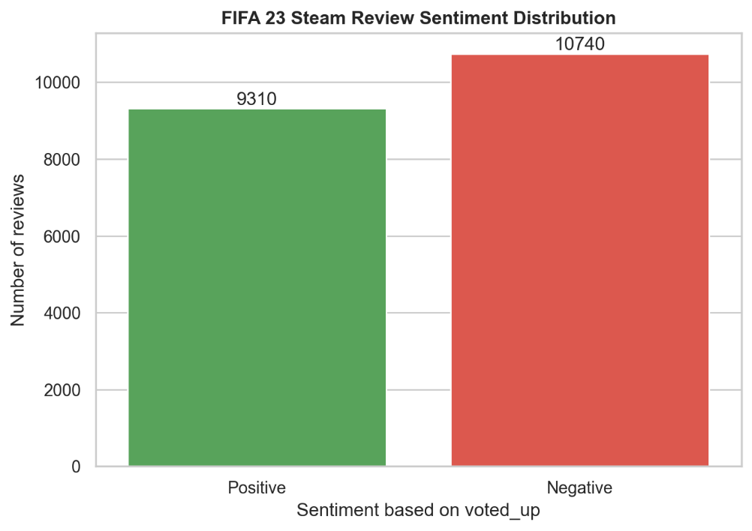
Figure ‎5.1: Stean Review Sentiment Distribution
VADER sentiment analysis is also applied to the review text as a lexicon-based comparison method. VADER produces a compound sentiment score, which can normally be interpreted using three classes: positive, neutral, and negative. In this project, the 3-class VADER rule is: positive if the compound score is greater than or equal to 0.05, neutral if the compound score is between -0.05 and 0.05, and negative if the compound score is less than or equal to -0.05.
Using this 3-class VADER interpretation, 7,167 reviews are classified as positive, representing 35.75% of the cleaned dataset. Another 6,224 reviews are classified as neutral, representing 31.04%, while 6,659 reviews are classified as negative, representing 33.21%. This descriptive result shows that the written tone of FIFA 23 reviews is more balanced than the Steam recommendation labels. Many reviews contain neutral or mixed wording, even though Steam itself only records the final recommendation as positive or negative.
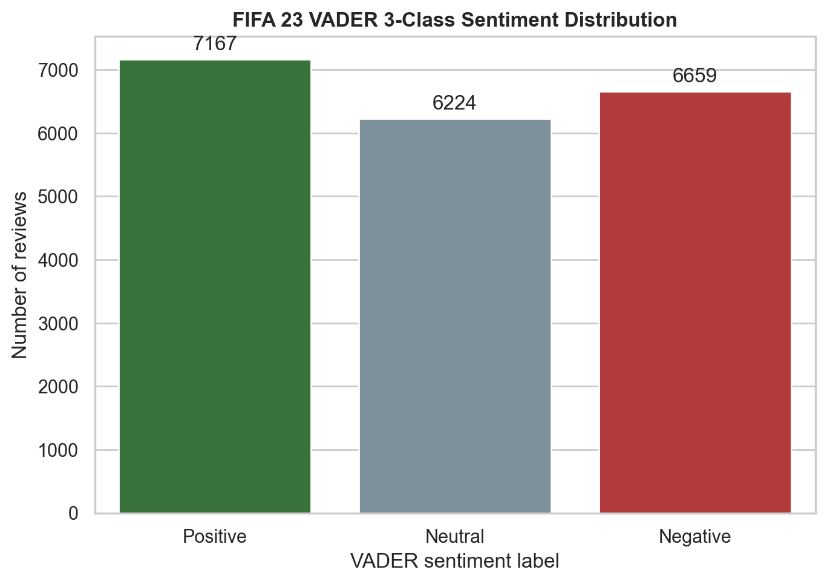
Figure ‎5.2: VADER 3-class sentiment distribution before binary conversion
For Hypothesis 4, VADER must be converted into a binary label because it is being compared directly with the Steam voted_up label. A confusion matrix requires both compared labels to have the same class structure. Since voted_up has no neutral class, VADER is converted using the binary rule: positive if the compound score is greater than or equal to 0, and negative if the compound score is less than 0.
After binary conversion, the VADER label is compared with the Steam voted_up label. The comparison shows an agreement rate of 69.36%. This means that in most cases, the written emotional tone of the review agrees with the Steam recommendation. However, around one-third of cases do not match. These mismatches are expected because Steam recommendation behaviour is not always the same as written sentiment.
Some players may use positive language while still not recommending the game because of price, bugs, online issues, or anti-cheat problems. Other players may write short, sarcastic, neutral, or mixed reviews that a lexicon-based method cannot interpret perfectly. Therefore, the VADER comparison supports Hypothesis 4 only partially: written sentiment and Steam recommendation are related, but they are not identical.
The VADER 3-class distribution is also used to create the target labels for the additional multi-class sentiment classification experiment. The distribution contains 6,659 Negative reviews, 6,224 Neutral reviews and 7,167 Positive reviews. These values represent 33.21%, 31.04% and 35.75% of the cleaned dataset respectively. This shows that the VADER-derived written sentiment labels are relatively balanced across the three classes.
However, these multi-class labels must be interpreted carefully. They are weak labels generated by a lexicon-based sentiment method, not manually annotated human labels. Therefore, they represent VADER-style written polarity rather than true human-labelled emotion. This is different from the binary voted_up task, where the model predicts the actual Steam recommendation outcome. The binary task remains the main supervised task because it uses the real label provided in the dataset, while the multi-class task is added to compare how different models perform when Neutral sentiment is included.
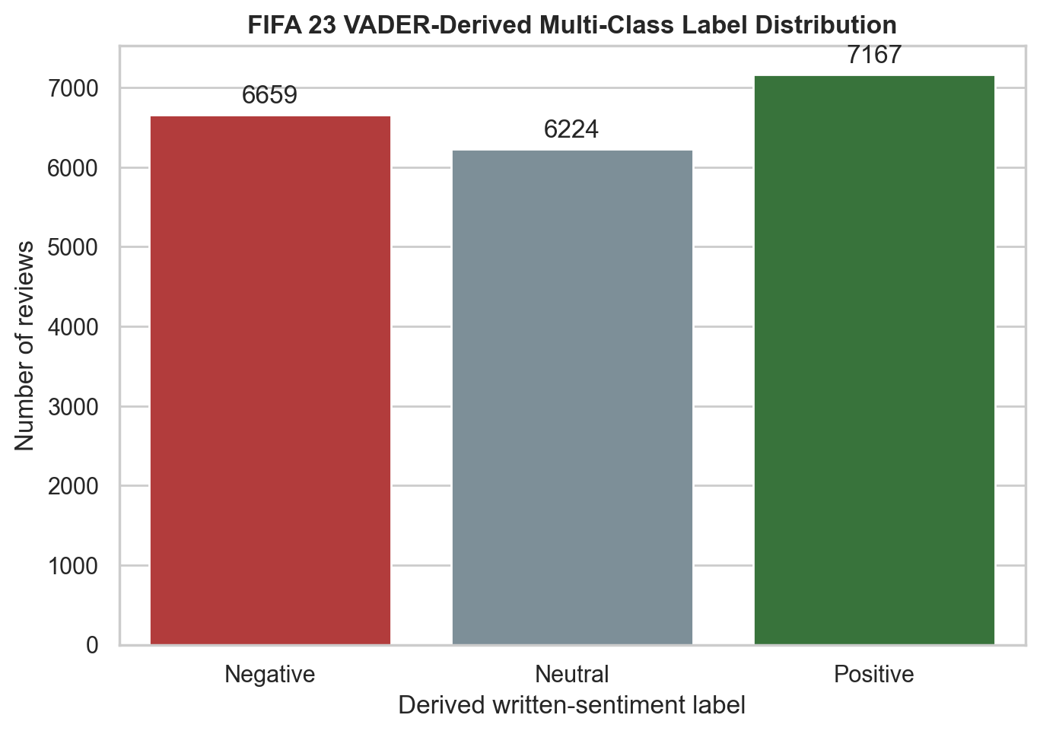
Figure ‎5.3: Distribution of VADER-derived multiclass sentiment labels

Transformers / Deep Learning Models
This section explains the deep learning and transformer-based components of the project. After tutor feedback, a trained BiLSTM Neural Network was added to satisfy the deep learning requirement. The DistilBERT SST-2 model is retained as a pretrained transformer benchmark, but it is not treated as the main trained deep learning model because it was not fine-tuned on the FIFA 23 Steam review dataset.
The BiLSTM Neural Network is the actual trained deep learning model in this project. It is trained directly on the cleaned FIFA 23 Steam reviews using the binary voted_up label. The model uses a TextVectorization layer to convert review text into numerical token sequences, followed by an Embedding layer that learns dense word representations. A Bidirectional LSTM layer is then used to learn sequential text patterns from both forward and backward directions. This is useful for review text because the meaning of a word may depend on both earlier and later words in the sentence.
The BiLSTM architecture also includes Dropout layers and a Dense hidden layer. Dropout is used to reduce overfitting by randomly disabling some neurons during training. The final output layer uses a sigmoid activation function because the task is binary classification. The model is trained using binary cross-entropy loss and the Adam optimizer. Early stopping is applied using a validation split so that training stops when validation performance no longer improves.
The BiLSTM Neural Network achieved an accuracy of 0.8404, precision of 0.8479, recall of 0.7997, and F1-score of 0.8231. This shows that the BiLSTM learned useful sentiment patterns from the review text. Although it did not outperform Logistic Regression, it performed better than Random Forest, Multinomial Naive Bayes, and the pretrained DistilBERT SST-2 benchmark. This confirms that the model is a valid trained deep learning model for the project.
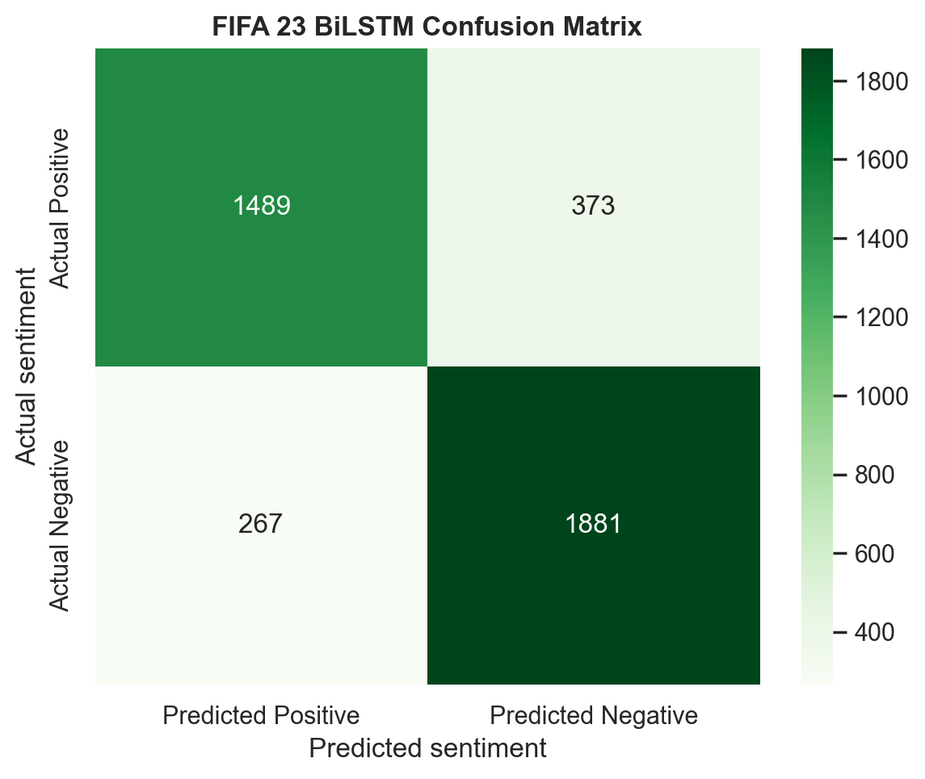
Figure ‎6.1: Confusion matrix for the trained BiLSTM neural network on the FIFA 23 Steam review test set.

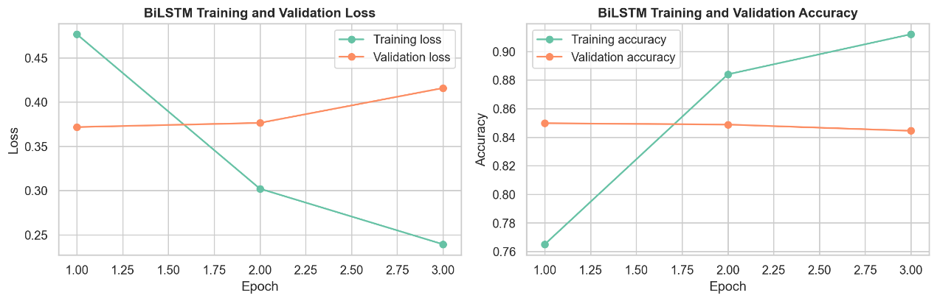
Figure ‎6.2: Training and validation loss/accuracy history for the BiLSTM neural network.
The BiLSTM model is also adapted for the multi-class sentiment classification experiment. In the binary task, the BiLSTM uses a sigmoid output layer to predict whether a review is positive or negative based on the Steam voted_up label. For the multi-class task, the output layer is changed to a softmax layer with three output units: Negative, Neutral, and Positive. This allows the model to predict one of the three VADER-derived sentiment categories.
The multi-class BiLSTM achieved an accuracy of 0.8429, macro F1-score of 0.8450, and weighted F1-score of 0.8436. This result shows that the BiLSTM can learn useful patterns from the review text for three-class written sentiment classification. However, the labels used in this experiment are generated from VADER compound scores, so the result should be understood as the model’s ability to reproduce VADER-style polarity categories rather than true human-labelled sentiment.
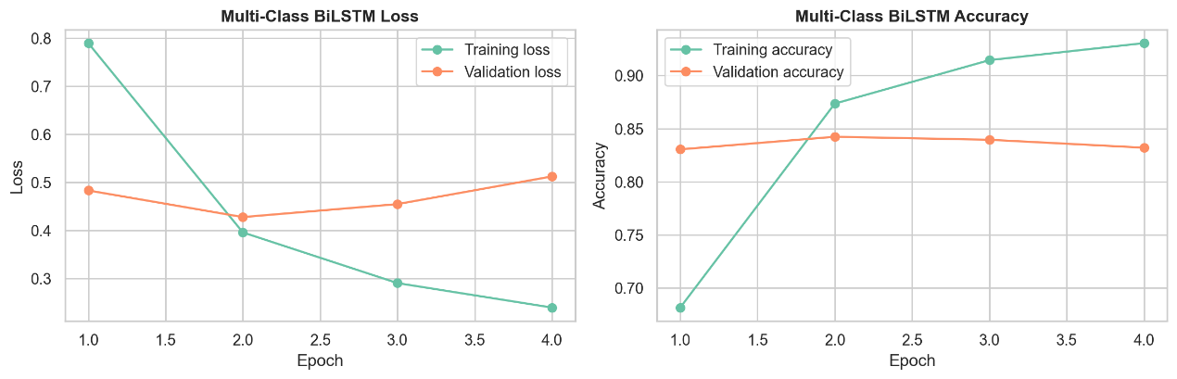
Figure ‎6.3: Training and validation history for the multi-class BiLSTM model.
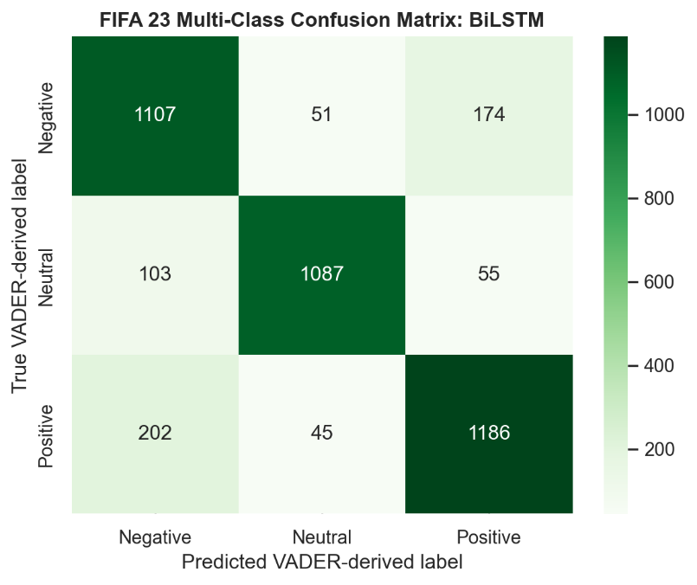
Figure ‎6.4: Confusion matrix for the multi-class BiLSTM neural network.
The DistilBERT SST-2 model is included as a pretrained transformer benchmark. Unlike the BiLSTM model, it is not trained on the FIFA 23 Steam dataset. Instead, it is applied through the Hugging Face Transformers pipeline. DistilBERT uses contextual word representations and can understand general sentiment patterns, but it may not fully match Steam review behaviour because it was trained on general sentiment data rather than gaming-specific review labels.
The DistilBERT SST-2 model achieved an accuracy of 0.7565, precision of 0.8184, recall of 0.6114, and F1-score of 0.6999. Its lower performance does not mean that transformer models are weak. Instead, it shows the importance of domain adaptation. Steam reviews often contain slang, sarcasm, mixed opinions, technical complaints, and recommendation decisions that are not always based only on emotional tone. In addition, the voted_up label reflects whether a player recommends FIFA 23, not whether every sentence in the review is positive or negative.
Overall, the BiLSTM model provides the trained deep learning component required for the project, while DistilBERT provides a useful pretrained transformer benchmark. The comparison shows that deep learning can learn meaningful review patterns, but domain-specific training and label design strongly affect model performance.

Result & Visualization
This section presents the main findings from the sentiment analysis, hypothesis testing, machine learning models, opinion mining; and aspect-based sentiment analysis. The results illustrate that FIFA 23 Steam reviews contain slightly more negative recommendations than positive recommendations with 10,740 negative reviews compared 9,310 positive reviews in the cleaned dataset. This indicates that the overall player response on Steam was mixed but, leaned more toward dissatisfaction.
The traditional machine learning results show that Logistic Regression achieved the best overall binary classification performance, with an accuracy of 0.8566 and F1-score of 0.8468. Linear SVM was the second-best model, with an F1-score of 0.8318. The trained BiLSTM Neural Network achieved an F1-score of 0.8231, while Random Forest and Multinomial Naive Bayes performed lower. The pretrained DistilBERT SST-2 transformer benchmark achieved an F1-score of 0.6999, which is lower than the supervised TF-IDF models and the trained BiLSTM model.
Table ‎7.1: Performance comparison of traditional ML, trained BiLSTM deep learning, and pretrained DistilBERT transformer models.
Model | Accuracy | Precision | Recall | F1-score
Logistic Regression | 0.8566 | 0.8403 | 0.8534 | 0.8468
Linear SVM | 0.8414 | 0.8193 | 0.8448 | 0.8318
BiLSTM Neural Network | 0.8404 | 0.8479 | 0.7997 | 0.8231
Random Forest | 0.8155 | 0.7802 | 0.8389 | 0.8085
Multinomial Naive Bayes | 0.7793 | 0.8621 | 0.6246 | 0.7244
Transformer DistilBERT SST-2 | 0.7565 | 0.8184 | 0.6114 | 0.6999

These results suggest that TF-IDF features combined with Logistic Regression remain the most effective approach for this dataset. The BiLSTM Neural Network also performs strongly, showing that a trained deep learning model can learn useful patterns from FIFA 23 review text. However, its lower F1-score compared with Logistic Regression suggests that the dataset and task are well suited to simpler linear text classifiers. The pretrained DistilBERT benchmark performs the lowest among the compared models because it was not fine-tuned on FIFA 23 Steam reviews or the voted_up recommendation label.
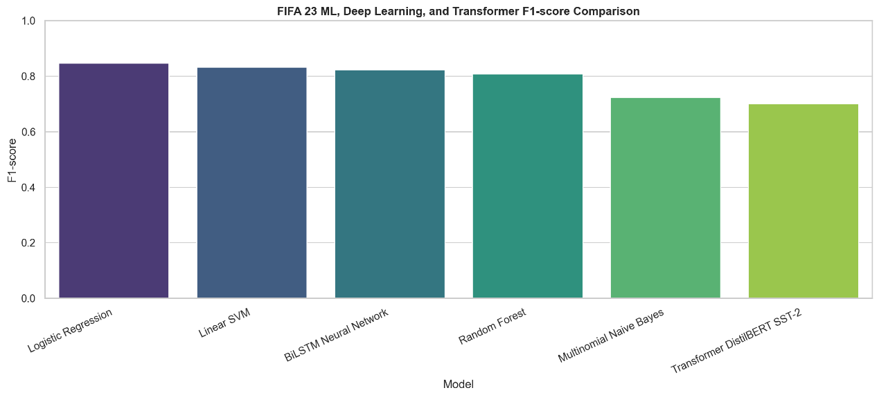
Figure ‎7.1: F1-score comparison across traditional ML, trained BiLSTM deep learning, and pretrained DistilBERT transformer models.
The hypothesis testing results also provide useful behavioural insights. Hypothesis 1 is supported because players with positive reviews had a higher median recent playtime of 5.07 hours, compared with 0.32 hours for negative reviews. This suggests that players who were recently active in the game were more likely to recommend it.
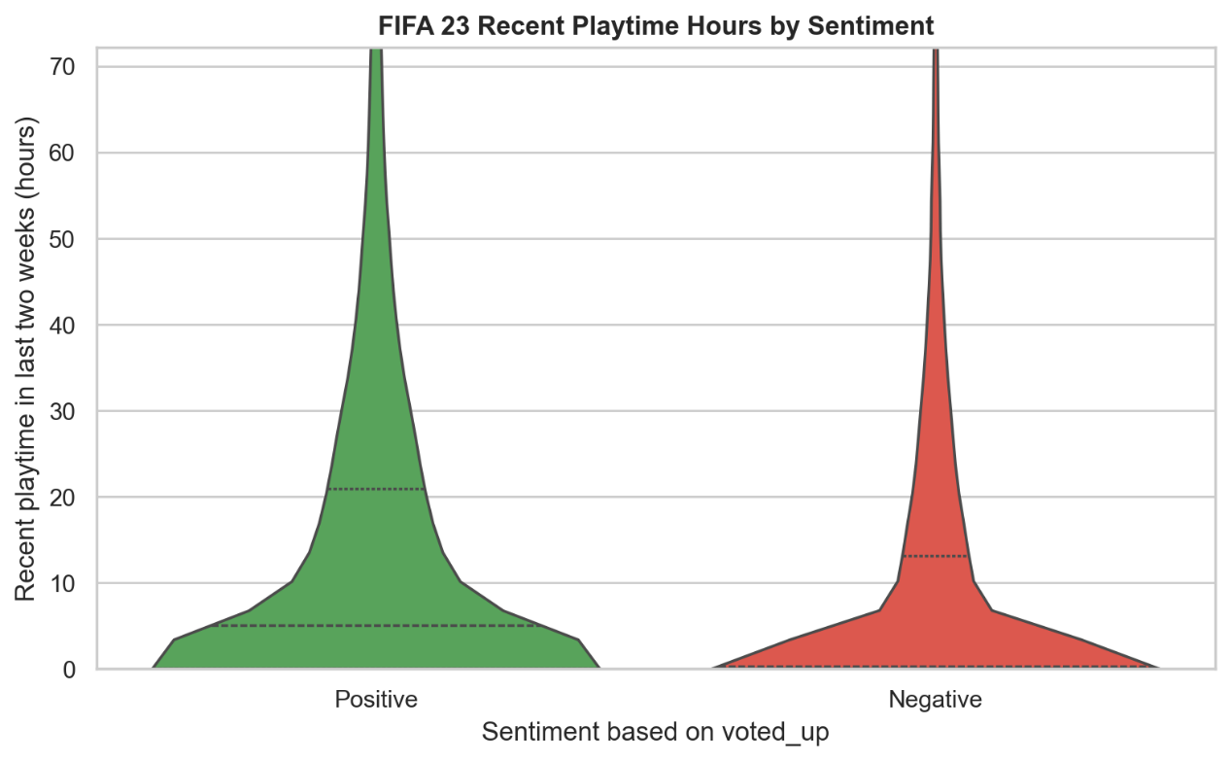
Figure ‎7.2: Recent playtime hours by Steam review sentiment.
Hypothesis 2 is also supported because negative reviewers had a higher median number of games owned, at 30 games compared with 16 games for positive reviewers. This may indicate that players with broader gaming experience are more critical in their evaluation.
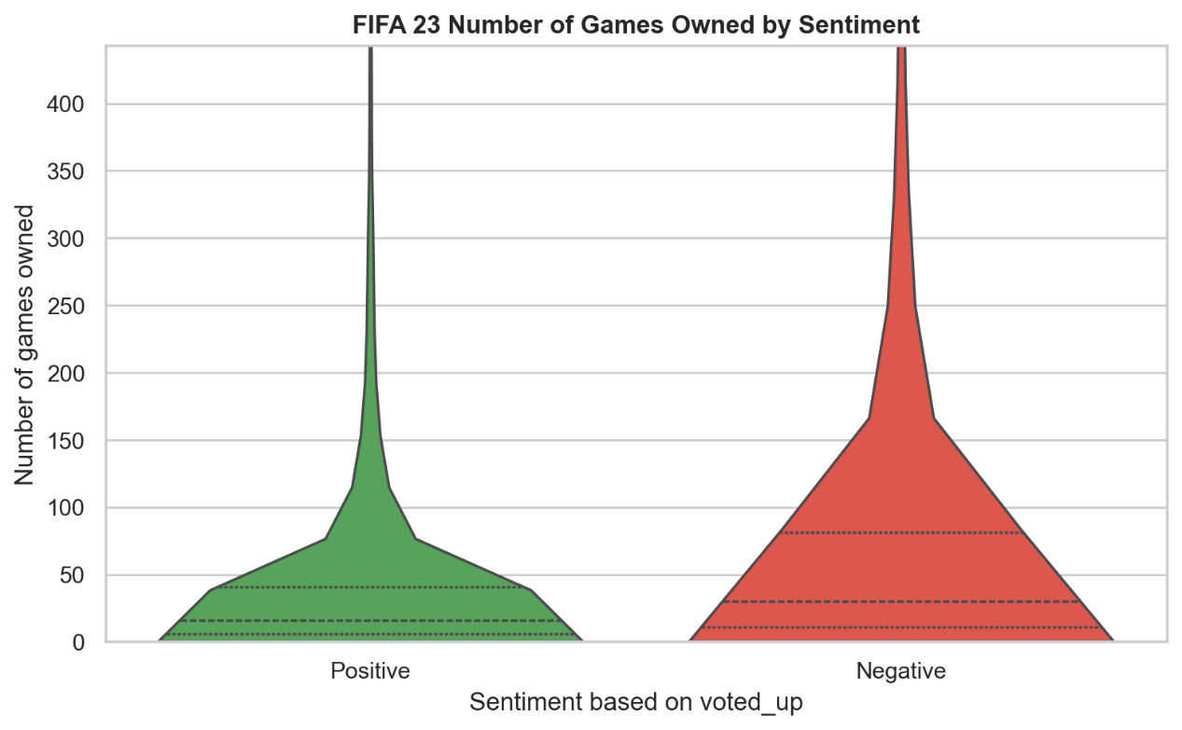
Figure ‎7.3: Number of games owned by Steam review sentiment.
Hypothesis 3 is supported because the chi-square test shows that sentiment changed significantly over time. The monthly trend shows that positive review percentage varied across the review period from September 2022 to March 2023. This suggests that player sentiment may have been affected by game updates, technical issues, online service quality, or changing player expectations after release.
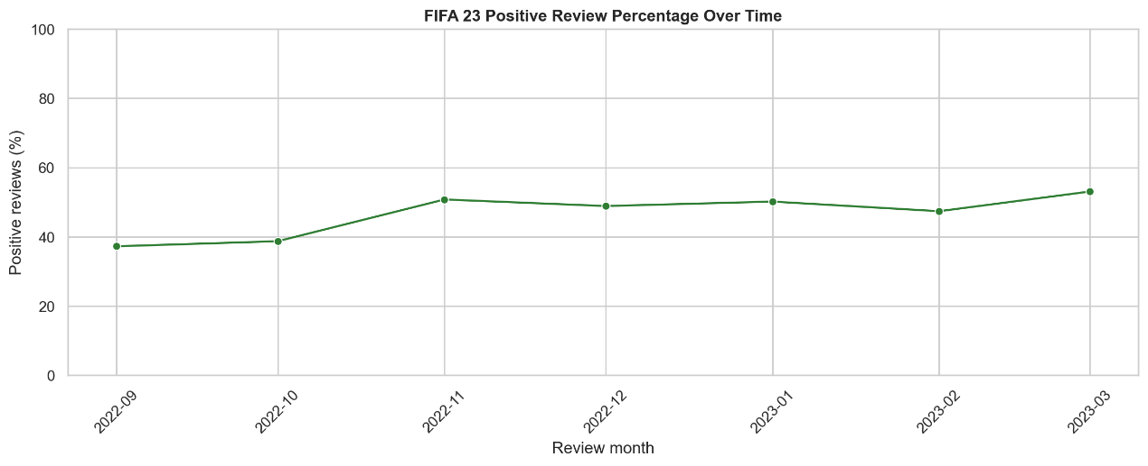
Figure ‎7.4: Average sentiment trend of FIFA 23 Steam reviews by month.
Hypothesis 4 is partially supported. VADER written sentiment agreed with the Steam voted_up label for 69.36% of cleaned reviews. This result depicts that the written sentiment and recommendation behaviour are related, but not exactly identical. The disagreement between the two labels is expected because Steam reviews often contain sarcasm, mixed opinions, short comments and sometimes complaints about specific issues even when the general language appears positive.
Before binary conversion, VADER was also examined using its standard 3-class sentiment interpretation. The 3-class VADER distribution contains 7,167 positive reviews, 6,224 neutral reviews, and 6,659 negative reviews. This shows that VADER identifies a large neutral portion in the written review text. However, this neutral category cannot be used directly as a supervised class because the Steam voted_up label only contains positive and negative recommendation outcomes. Therefore, the 3-class VADER output is used descriptively, while the binary VADER output is used for direct comparison with voted_up.
Table ‎7.2: Statistical hypothesis testing results for player behavior and sentiment patterns.
Hypothesis | Test | Main Result | Interpretation
H1: Higher recent playtime relates to positive reviews | Mann-Whitney U | p = 5.921e-121; positive median = 5.07 hours; negative median = 0.32 hours | Supported
H2: More games owned relates to negative reviews | Mann-Whitney U | p = 7.634e-187; positive median = 16; negative median = 30 | Supported
H3: Sentiment changes over time | Chi-square | p=7.256e-43; sentiment distribution changes significantly over time. | Supported
H4: Written sentiment agrees with voted_up | VADER agreement | VADER binary sentiment agrees with voted_up for 69.36% of cleaned reviews. Mismatches may indicate sarcasm, slang, short text, or mixed opinions. | Partially supported

The opinion mining results show that positive reviews commonly include phrases such as “good game,” “best game,” “great game,” “ultimate team,” “nice game,” “next gen,” and “amazing game.” These phrases suggest that positive reviewers often focus on overall enjoyment, football experience, and game modes. Negative reviews include phrases such as “launch game,” “anti cheat,” “worst game,” “shit game,” “open game,” “able play,” “bad game,” “fix game,” and “cant play.” These phrases show that many negative reviews are related to launch problems, technical barriers, anti-cheat issues, and gameplay frustration.
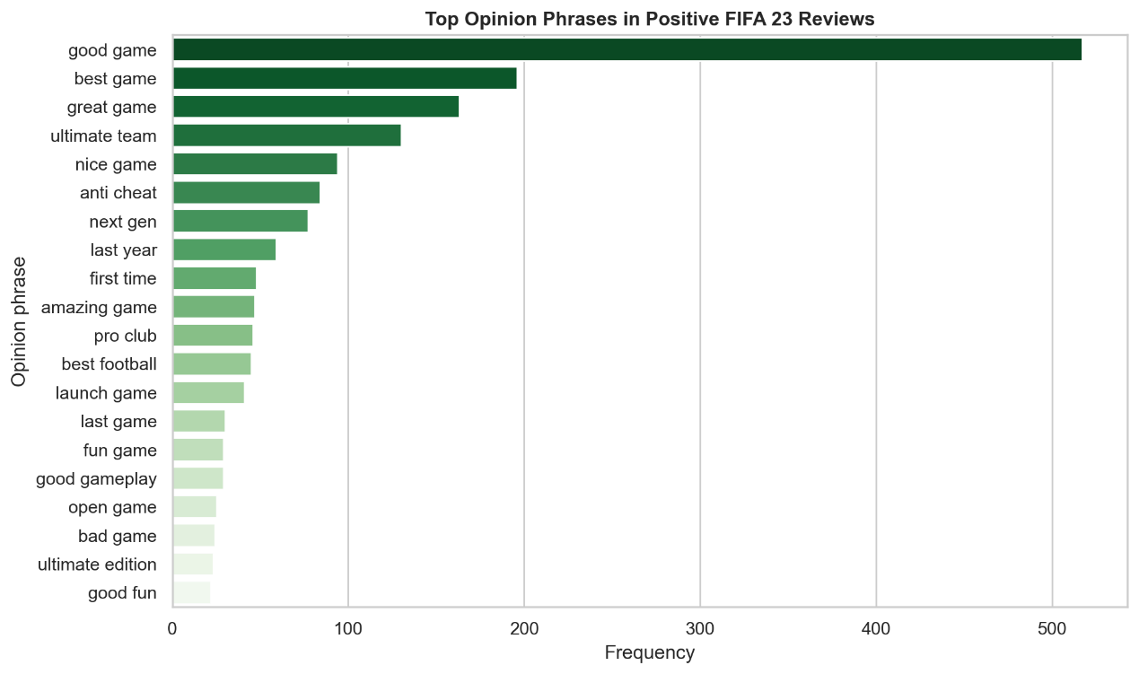
Figure ‎7.5: Top positive opinion phrases in FIFA 23 Steam reviews.
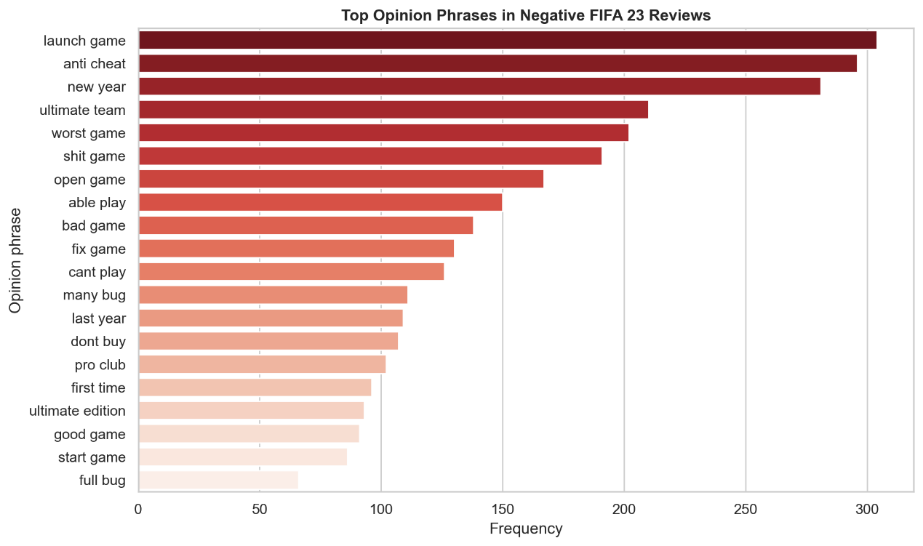
Figure ‎7.6: Top negative opinion phrases in FIFA 23 Steam reviews.
The aspect-based sentiment analysis provides the clearest insight into what players liked and disliked. Price/Monetization received the highest number of aspect mentions, with 4,207 mentions, and it was strongly negative, with 84.22% negative sentiment. Servers/Online was also highly negative, with 83.22% negative sentiment, while Performance/Bugs had 80.05% negative sentiment. These results show that many player complaints were not only about gameplay itself, but also about technical stability, online experience, and perceived value for money. Graphics was the most positive aspect, with 56.25% positive sentiment, suggesting that visual presentation was one of the stronger areas of FIFA 23.
Table ‎7.3: Aspect-based sentiment results for FIFA 23 Steam reviews.
Aspect | Total Mentions | Positive % | Negative %
Gameplay | 2,197 | 33.96% | 66.04%
Graphics | 752 | 56.25% | 43.75%
Performance/Bugs | 2,241 | 19.95% | 80.05%
Servers/Online | 721 | 16.78% | 83.22%
Career/Content | 1,769 | 35.56% | 64.44%
Price/Monetization | 4,207 | 15.78% | 84.22%

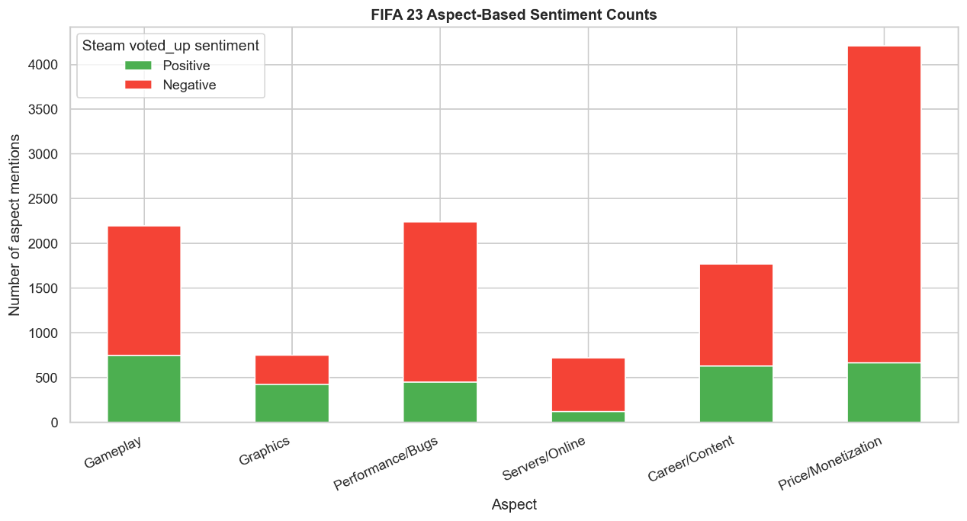
Figure ‎7.7: Aspect-based positive and negative sentiment distribution for FIFA 23 Steam reviews.
Overall, the results show that FIFA 23’s negative Steam reception was mainly driven by monetization/value concerns, online server problems, performance issues, bugs, and anti-cheat complaints. The game still received positive feedback for graphics, some gameplay experiences, and popular modes such as Ultimate Team, but these strengths were not enough to remove dissatisfaction from other major areas.
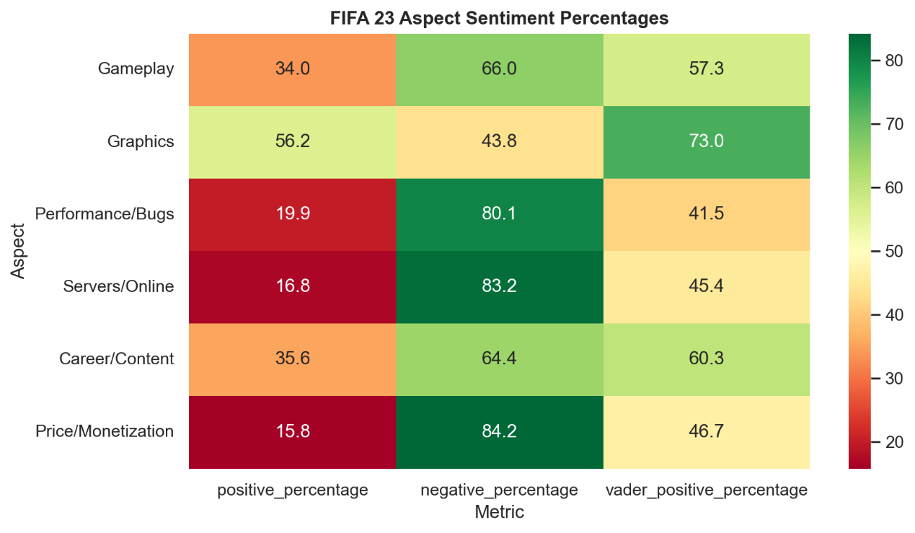
Figure ‎7.8: Heatmap of positive and negative sentiment percentages by game aspect.
An additional multi-class sentiment classification experiment was conducted using VADER-derived weak labels. Unlike the binary voted_up task, this experiment classifies review text into Negative, Neutral, and Positive categories. The purpose is to compare model behaviour when a neutral written-sentiment class is included. However, the results should not be interpreted as human-labelled sentiment classification because the labels are derived from VADER compound scores.
Table 4 shows the multi-class model comparison. Logistic Regression achieved the best overall performance, with an accuracy of 0.8511, macro F1-score of 0.8511, and weighted F1-score of 0.8503. Linear SVM achieved the second-best result, with a macro F1-score of 0.8473. The multi-class BiLSTM Neural Network achieved a macro F1-score of 0.8450, which is close to the Linear SVM result and higher than Random Forest and Multinomial Naive Bayes. This shows that the BiLSTM model performed strongly in the multi-class experiment, although Logistic Regression remained the best model overall.

Table ‎7.4: Multi-class sentiment classification results using VADER-derived weak labels.
Model | Accuracy | Macro F1 | Weighted F1
Logistic Regression | 0.8511 | 0.8511 | 0.8503
Linear SVM | 0.8474 | 0.8473 | 0.8463
BiLSTM Neural Network | 0.8429 | 0.8450 | 0.8436
Random Forest | 0.7890 | 0.7883 | 0.7872
Multinomial Naive Bayes | 0.6845 | 0.6630 | 0.6670

The multi-class results show a similar pattern to the binary classification results. Logistic Regression and Linear SVM remain strong because TF-IDF features capture important sentiment-related words effectively. The BiLSTM model also performs well because it can learn sequential patterns from the review text. However, Multinomial Naive Bayes performs lower in the multi-class setting, which may be because the Neutral class is harder to separate using simple word probability assumptions.
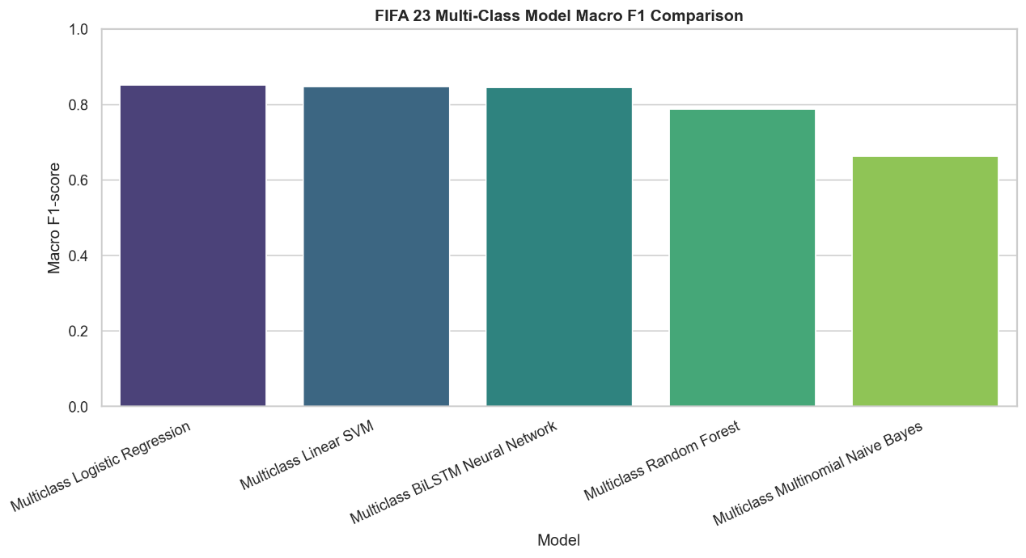
Figure ‎7.9: Macro F1-score comparison for multi-class sentiment models.
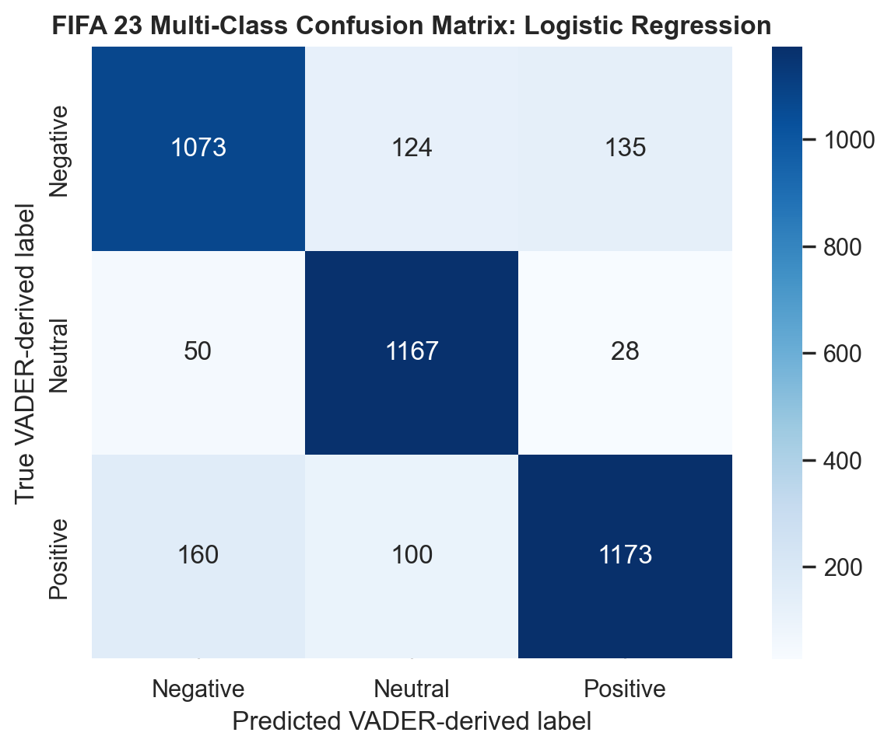
Figure ‎7.10: Confusion matrix for the best multi-class model (LR).
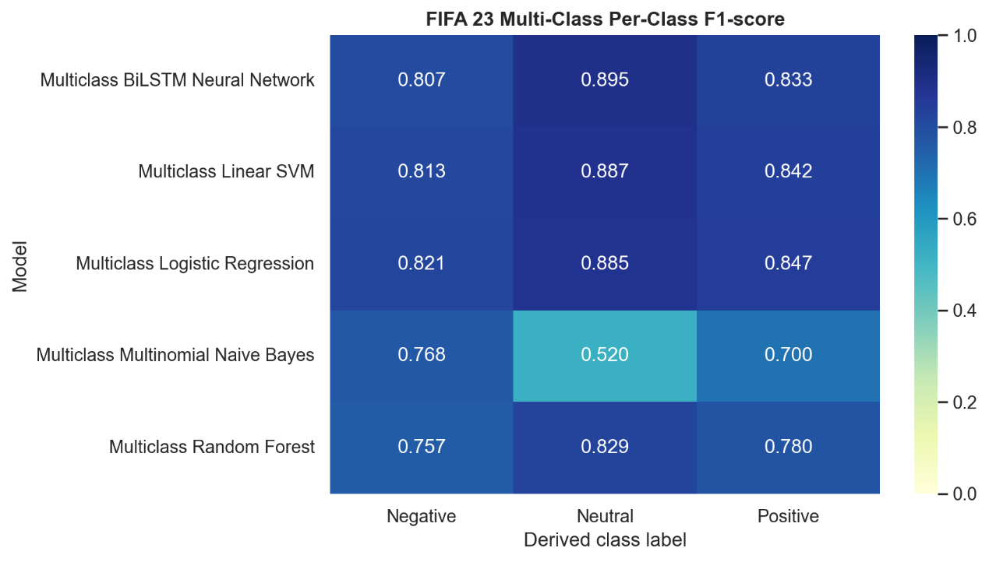
Figure ‎7.11: Per-class F1-score heatmap for multi-class sentiment models.

Discussion
The findings show that FIFA 23 received mixed but mostly critical feedback from Steam reviewers. The cleaned dataset contains more negative than positive reviews, which suggests that many players were dissatisfied with the game during the analysed period. However, the results also show that negative sentiment was not caused by one single issue. Instead, player dissatisfaction came from several connected areas, especially monetization, technical performance, bugs, online servers, and anti-cheat problems.
The best-performing model was Logistic Regression using TF-IDF features. This result is reasonable because TF-IDF works well for short and medium-length review texts where important keywords strongly indicate sentiment. Logistic Regression also handles high-dimensional sparse text features effectively and is easier to interpret compared with more complex models. Linear SVM performed second best, which also supports the suitability of traditional linear classifiers for text classification tasks.
The BiLSTM Neural Network achieved strong performance and confirms that the project includes a true trained deep learning model. Its F1-score of 0.8231 shows that the model was able to learn useful sentiment patterns from the cleaned FIFA 23 review text. However, it still performed slightly below Logistic Regression and Linear SVM. One reason is that the review dataset contains many short, direct, and keyword-heavy texts. For this type of data, TF-IDF with linear classifiers can be very effective because words such as “broken,” “lag,” “good,” “fun,” “refund,” and “crash” directly contribute to sentiment and recommendation decisions.
The BiLSTM model uses word embeddings and sequential learning, which can capture word order and context better than TF-IDF. However, neural networks usually require more data, careful tuning, and longer training time to outperform strong traditional baselines. The BiLSTM result is still valuable because it outperformed Random Forest, Multinomial Naive Bayes, and the pretrained DistilBERT benchmark. This shows that a compact neural network can learn meaningful review patterns, even though Logistic Regression remains the most suitable model for this dataset.
The pretrained DistilBERT SST-2 transformer model performed below both the supervised TF-IDF models and the trained BiLSTM model. This result is important because it shows that a more advanced pretrained model is not always better when it is not fine-tuned on the same domain and label definition. DistilBERT understands general positive and negative language, but Steam voted_up is a recommendation label. Players may recommend or not recommend the game based on overall value, technical problems, online stability, anti-cheat issues, or personal expectations, even when the wording of the review is mixed. Therefore, the DistilBERT result highlights the importance of fine-tuning transformer models on task-specific data.The hypothesis testing results provide useful insight into player behaviour. Positive reviewers had much higher recent playtime than negative reviewers. This suggests that players who were still actively playing FIFA 23 were more likely to recommend it. In contrast, negative reviewers had a higher median number of games owned. This may suggest that players with more gaming experience compare FIFA 23 with other games and may judge it more critically.
The monthly sentiment result shows that player opinion changed significantly over time. This is expected in gaming communities because player sentiment can shift after launch, updates, server problems, patches, or gameplay changes. For live-service and online games, sentiment is not fixed at release. It can improve or decline depending on how quickly developers respond to player complaints.
The VADER comparison also shows that written sentiment and Steam recommendation are related but not identical. The 69.36% agreement rate indicates that VADER captures many cases correctly, but it misses some Steam-specific meanings. Sarcasm, slang, short reviews, and mixed opinions are common in gaming reviews. For example, players may use positive words while complaining about anti-cheat, or they may write emotional negative comments after a bad online match. This explains why lexicon-based sentiment analysis alone is not enough for this dataset.
The VADER 3-class distribution also helps explain why binary classification was used carefully in this project. VADER can classify written text as positive, neutral, or negative, and the descriptive result shows a large neutral group. However, the supervised dataset does not contain a neutral recommendation label. Since Steam only provides voted_up=True or voted_up=False, neutral cannot be used as a supervised class without manual annotation. For this reason, the main classification task remains binary, while the VADER 3-class result is used only as descriptive evidence of written sentiment tone.
The multi-class experiment provides an additional view of written sentiment by including a Neutral class. However, this experiment is different from the main binary classification task. The binary models are trained using the actual Steam voted_up label, while the multi-class models are trained using VADER-derived weak labels. Therefore, the multi-class results measure how well the models can reproduce VADER-style written polarity categories, not how well they predict manually annotated human emotion.
Logistic Regression achieved the highest macro F1-score in the multi-class experiment. This suggests that TF-IDF features are still highly effective for review sentiment classification, even when a Neutral class is added. The BiLSTM model also performed strongly, with a macro F1-score of 0.8450, showing that a neural network can learn useful three-class sentiment patterns from the review text. However, because the multi-class labels are generated using VADER, any limitations of VADER, such as difficulty with sarcasm, slang, gaming expressions, and mixed opinions, may also influence the multi-class model results.
The Neutral class should also be interpreted carefully. In this project, Neutral does not mean that a human annotator judged the review to be neutral. It means that the VADER compound score falls between -0.05 and 0.05. These reviews may be short, factual, unclear, mixed, or low in emotional language. Therefore, the multi-class experiment is useful for comparison and analysis, but the binary voted_up task remains the main supervised classification task.
The aspect-based sentiment results are the most useful for practical recommendations. Price/Monetization, Servers/Online, and Performance/Bugs are the most negative aspects. These areas should be the main focus for developers because they directly affect whether players feel the game is fair, stable, and worth buying. Graphics is the most positive aspect, which suggests that visual quality was not the main cause of dissatisfaction. Therefore, improving technical stability, online reliability, anti-cheat systems, and value perception would likely have a stronger impact on player satisfaction than improving visuals alone.
There are also limitations in this project. First, the voted_up label is treated as the supervised sentiment label, but it represents recommendation behaviour rather than pure emotion. Second, the aspect-based sentiment analysis uses predefined keyword dictionaries, so it may miss opinions that use unexpected words or indirect expressions. Third, the transformer model was used as a pretrained benchmark and was not fine-tuned on the FIFA 23 dataset. Despite these limitations, the project provides a clear and useful overview of FIFA 23 player sentiment and the main reasons behind positive and negative Steam reviews.

Conclusion & Future Work
This project developed an end-to-end sentiment analysis and opinion mining pipeline for FIFA 23 Steam reviews. The study used the Steam voted_up column as the supervised label, where positive reviews represent recommended reviews and negative reviews represent not recommended reviews. After cleaning the dataset, 20,050 reviews were analysed, consisting of 9,310 positive reviews and 10,740 negative reviews.
The results show that FIFA 23 received mixed feedback on Steam, with negative reviews slightly higher than positive reviews. Logistic Regression achieved the best overall model performance, with an F1-score of 0.8468. Linear SVM was the second-best model, while the trained BiLSTM Neural Network achieved an F1-score of 0.8231. The BiLSTM model satisfies the deep learning requirement because it was trained directly on the cleaned FIFA 23 Steam reviews using text vectorization, embeddings, a Bidirectional LSTM layer, dropout, and early stopping. Although it did not outperform Logistic Regression, it performed better than Random Forest, Multinomial Naive Bayes, and the pretrained DistilBERT SST-2 benchmark.
The hypothesis testing results showed significant relationships between sentiment and player behaviour. Players with higher recent playtime were more likely to leave positive reviews, while players who owned more games were more likely to leave negative reviews. Sentiment also changed significantly over time, showing that player opinion was not stable across the review period. VADER sentiment was first examined using a 3-class Positive, Neutral, and Negative distribution, but it was converted into binary sentiment for direct comparison with the Steam voted_up label. This was necessary because voted_up does not contain a neutral class. The binary VADER sentiment agreed with Steam voted_up labels for 69.36% of cleaned reviews, showing that written sentiment and recommendation behaviour are related but not exactly the same.
The opinion mining and aspect-based sentiment analysis provided deeper insight into the reasons behind player feedback. Positive reviews commonly mentioned phrases such as “good game,” “best game,” and “great game,” while negative reviews included phrases such as “anti cheat,” “worst game,” “bad game,” “fix game,” and “cant play.” The most negative aspects were Price/Monetization, Servers/Online, and Performance/Bugs. Graphics was the most positive aspect. These findings suggest that player dissatisfaction was mainly caused by perceived value, online stability, technical issues, and gameplay-related frustration rather than visual quality.
Several challenges were faced during the project. One challenge was cleaning noisy review text because Steam reviews contain slang, short comments, informal language, and repeated phrases. Another challenge was interpreting the voted_up label because it represents recommendation status, not pure emotional sentiment. The transformer model also showed that general pretrained sentiment models may not match domain-specific recommendation labels without fine-tuning. These challenges were handled by keeping both raw and cleaned review text, comparing supervised labels with VADER written sentiment, and using error analysis to better understand mismatches.
The project also added a multi-class sentiment classification experiment using VADER-derived weak labels. In this experiment, reviews were classified into Negative, Neutral, and Positive categories based on VADER compound score thresholds. Logistic Regression achieved the best multi-class performance, with a macro F1-score of 0.8511, followed by Linear SVM and the BiLSTM Neural Network. These results show that the models can learn VADER-style written sentiment categories effectively. However, the multi-class labels are not manual human annotations, so the results should be interpreted as weak-label sentiment classification rather than true human-labelled emotion detection.
For future work, a manually annotated sentiment dataset could be created by labelling a sample of FIFA 23 reviews as Positive, Neutral, or Negative. This would allow a more reliable multi-class classification task instead of relying on VADER-derived weak labels. Future work could also fine-tune DistilBERT or another transformer model directly on FIFA 23 Steam reviews, especially for detecting neutral, mixed, sarcastic, or context-dependent gaming reviews. The BiLSTM model could also be improved through hyperparameter tuning, larger embedding dimensions, different sequence lengths, pretrained word embeddings, or comparison with GRU and CNN-based neural networks. The aspect-based sentiment analysis can also be improved by expanding the aspect dictionaries with more football-specific and EA-specific terms.
Overall, this project shows that sentiment analysis and opinion mining can provide useful insight into player experiences in online gaming communities. The findings can help developers and publishers understand what players value, what causes dissatisfaction, and which areas should be prioritized for improvement.

References
[1] B. Liu, Sentiment Analysis and Opinion Mining. San Rafael, CA, USA: Morgan & Claypool Publishers, 2012.
[2] B. Pang and L. Lee, “Opinion mining and sentiment analysis,” Foundations and Trends in Information Retrieval, vol. 2, no. 1-2, pp. 1-135, 2008, doi: 10.1561/1500000011.
[3] C. J. Hutto and E. Gilbert, “VADER: A parsimonious rule-based model for sentiment analysis of social media text,” in Proceedings of the International AAAI Conference on Web and Social Media, vol. 8, no. 1, pp. 216-225, 2014, doi: 10.1609/icwsm.v8i1.14550.
[4] F. Pedregosa et al., “Scikit-learn: Machine learning in Python,” Journal of Machine Learning Research, vol. 12, pp. 2825-2830, 2011.
[5] S. Bird, E. Klein, and E. Loper, Natural Language Processing with Python: Analyzing Text with the Natural Language Toolkit. Sebastopol, CA, USA: O’Reilly Media, 2009.
[6] J. Devlin, M.-W. Chang, K. Lee, and K. Toutanova, “BERT: Pre-training of deep bidirectional transformers for language understanding,” in Proceedings of NAACL-HLT 2019, pp. 4171-4186, 2019, doi: 10.18653/v1/N19-1423.
[7] V. Sanh, L. Debut, J. Chaumond, and T. Wolf, “DistilBERT, a distilled version of BERT: Smaller, faster, cheaper and lighter,” arXiv preprint arXiv:1910.01108, 2019.
[8] T. Wolf et al., “Transformers: State-of-the-art natural language processing,” in Proceedings of the 2020 Conference on Empirical Methods in Natural Language Processing: System Demonstrations, pp. 38-45, 2020, doi: 10.18653/v1/2020.emnlp-demos.6.
[9] Noahx1, “Fifa 23 Steam Reviews,” Kaggle. Accessed: Jun. 1, 2026. [Online]. Available: https://www.kaggle.com/datasets/noahx1/fifa-23-steam-reviews
[10] S. Loria, “TextBlob: Simplified Text Processing,” TextBlob Documentation. Accessed: Jun. 1, 2026. [Online]. Available: https://textblob.readthedocs.io/
[11] D. Jurafsky and J. H. Martin, Speech and Language Processing, 3rd ed. draft, 2021. [Online]. Available: https://web.stanford.edu/~jurafsky/slp3/

